25.30: With the 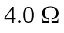 load, where r = internal resistance
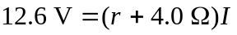
Change in terminal voltage:
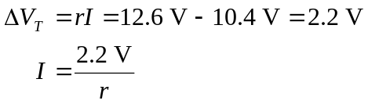
Substitute for I: 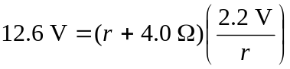
Solve for r: 